What is Databricks Delta Lake?
Introduction
Databricks Delta Lake is an open-source storage layer developed by Databricks that brings reliability, performance, and advanced data management capabilities to data lakes. It combines the scalability and flexibility of a data lake with the reliability and transactional capabilities of a traditional data warehouse.
Delta Lake is built on top of existing cloud storage systems and stores data in Parquet format while maintaining a transaction log called _delta_log. This transaction log records every change made to the data, enabling features such as ACID transactions, schema enforcement, schema evolution, time travel, and data versioning.
As organizations generate massive amounts of data, traditional data lakes often face challenges such as data inconsistency, poor data quality, lack of transaction support, and difficulties in managing updates and deletes. Delta Lake addresses these limitations by providing a reliable and efficient framework for managing large-scale data.

Need for Delta Lake
Traditional data lakes provide scalable and low-cost storage but have several limitations:
- Lack of ACID transaction support
- Data corruption during concurrent reads and writes
- Difficulty handling schema changes
- No built-in support for updates and deletes
- Poor data governance and auditing capabilities
- Challenges in maintaining data quality
Delta Lake was introduced to solve these problems by adding a transactional layer on top of data lakes while maintaining the scalability and flexibility of cloud storage.

Architecture of Delta Lake
The architecture of Delta Lake consists of three main components:
1. Data Files
The actual data is stored in Parquet files. Parquet is a columnar storage format that provides efficient compression and query performance.
2. Transaction Log (_delta_log)
The _delta_log directory contains transaction records that track every operation performed on the table. These logs maintain consistency and allow Delta Lake to support ACID transactions and data versioning.
3. Metadata
Metadata includes information about table schemas, partitions, table properties, and other configurations required for managing data efficiently.
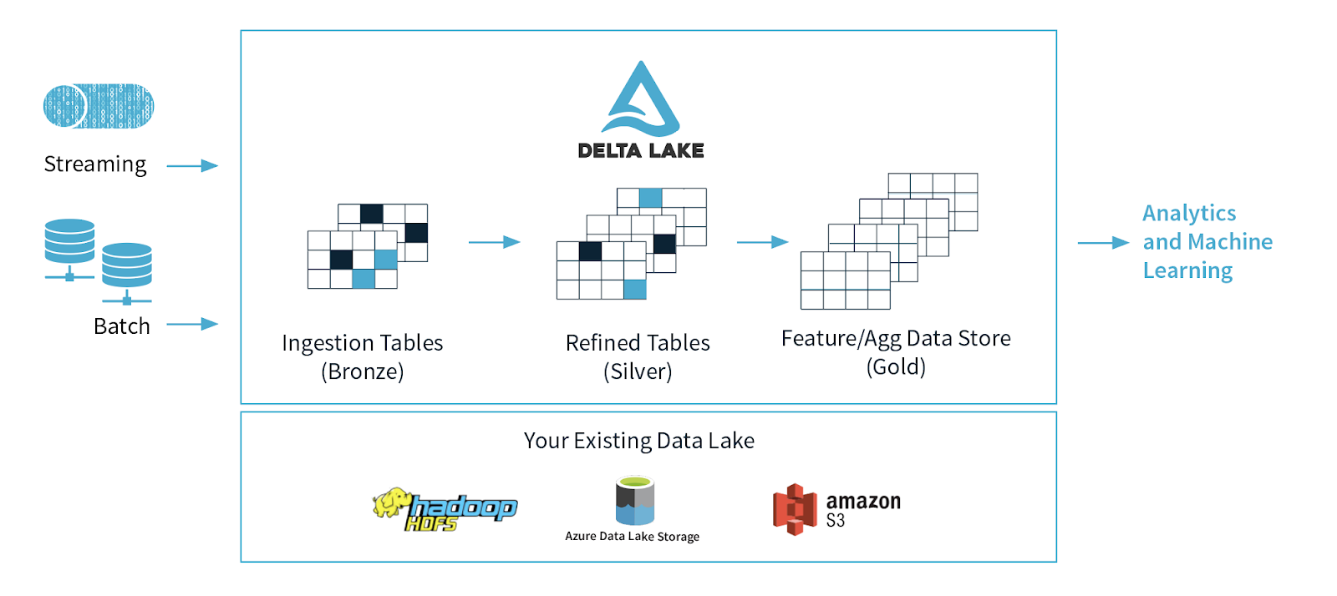

Key Features of Delta Lake
ACID Transactions
Delta Lake provides full ACID (Atomicity, Consistency, Isolation, Durability) transaction support. This ensures that data operations are completed reliably and consistently even when multiple users access the data simultaneously.
ACID transactions help prevent data corruption and maintain data integrity across large-scale distributed systems.
Schema Enforcement
Schema enforcement ensures that incoming data matches the existing table schema before it is written. If the schema does not match, Delta Lake rejects the data.
This feature improves data quality and prevents accidental introduction of invalid data.
Schema Evolution
Schema evolution allows controlled modifications to table schemas when business requirements change. New columns can be added without recreating the entire table.
This makes Delta Lake flexible and adaptable to evolving datasets.
Time Travel
Time travel allows users to access previous versions of a table. Since every modification is recorded in the transaction log, users can query historical versions of data.
This feature is useful for auditing, debugging, compliance, and recovering accidentally modified or deleted data.
Data Versioning
Every write operation creates a new version of the table. Delta Lake maintains a complete history of changes, enabling easy tracking and rollback of data.
Data versioning supports data governance and improves transparency.
Upsert Operations
Delta Lake supports upserts through the MERGE operation. This allows users to update existing records and insert new records in a single command.
Upsert functionality simplifies ETL and data integration processes.
Update and Delete Support
Unlike traditional data lakes, Delta Lake supports direct update and delete operations on datasets.
This capability simplifies data maintenance and enables efficient management of large datasets.
Data Compaction
As data is continuously written, many small files can accumulate and negatively impact query performance. Delta Lake provides optimization features that combine small files into larger files.
This process improves storage efficiency and accelerates query execution.
Z-Ordering
Z-Ordering is a performance optimization technique that reorganizes data based on frequently queried columns.
This reduces the amount of data scanned during query execution and significantly improves performance.
Unified Batch and Streaming Processing
Delta Lake supports both batch processing and real-time stream processing using the same storage layer.
This unified architecture simplifies data pipelines and reduces operational complexity.
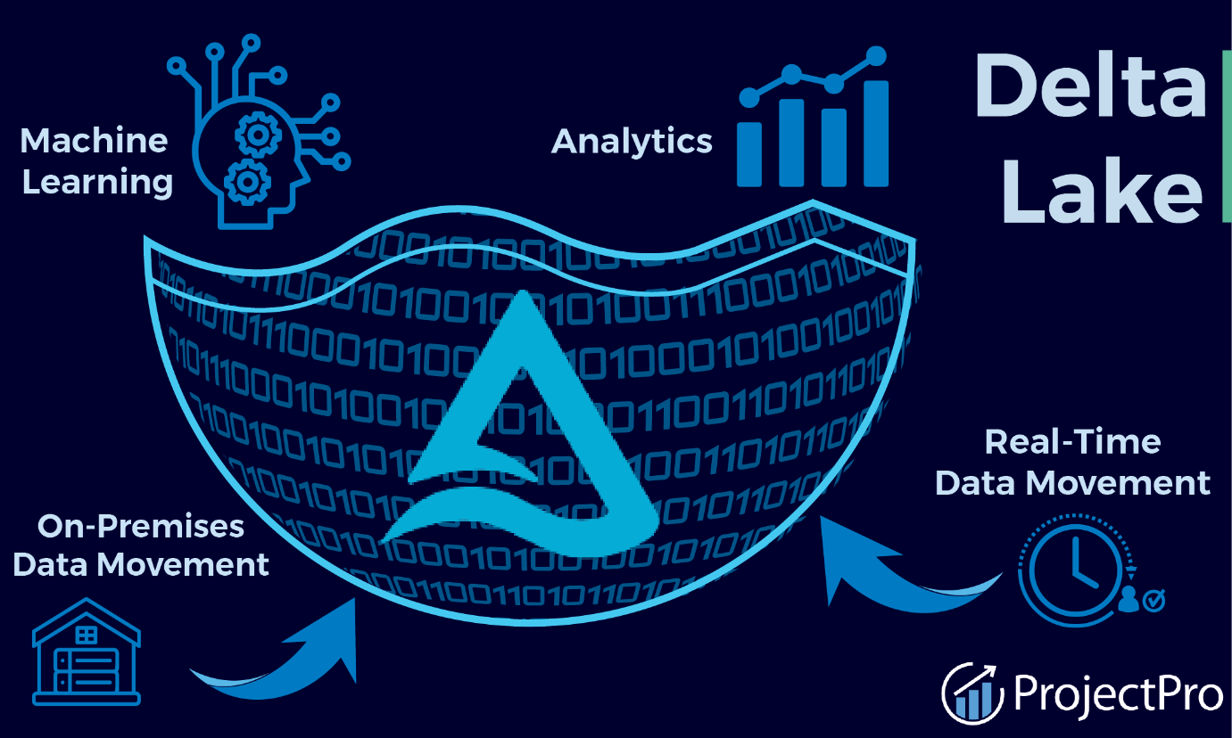
Advantages of Delta Lake
Delta Lake offers numerous advantages for modern data engineering and analytics workloads:
- Provides reliable ACID transactions
- Improves data consistency and integrity
- Supports schema validation and evolution
- Enables historical data access through time travel
- Maintains complete data version history
- Supports update, delete, and merge operations
- Enhances query performance through optimization techniques
- Supports both batch and streaming workloads
- Simplifies ETL and ELT processes
- Reduces risks of data corruption
- Improves data governance and auditing
- Scales efficiently for large datasets

Delta Lake Compared to Traditional Data Lakes
Traditional data lakes focus primarily on storing large volumes of data at low cost. However, they often lack transaction management and advanced data governance features.
Delta Lake enhances traditional data lakes by adding:
- Transaction support
- Data reliability
- Schema management
- Historical data tracking
- Performance optimization
- Simplified data maintenance
As a result, Delta Lake combines the benefits of data lakes and data warehouses into a single architecture known as a Lakehouse.

Common Operations in Delta Lake
Delta Lake supports various data management operations including:
- Creating Delta tables
- Reading Delta tables
- Inserting records
- Updating records
- Deleting records
- Merging datasets
- Viewing table history
- Optimizing table storage
- Cleaning unused files
- Managing schema changes
These operations make Delta Lake suitable for enterprise-scale analytics environments.

Real-World Applications of Delta Lake
Retail
Delta Lake is used for sales analytics, inventory management, customer behavior analysis, and demand forecasting.
Banking and Finance
Financial institutions use Delta Lake for fraud detection, transaction monitoring, risk assessment, and regulatory reporting.
Healthcare
Healthcare organizations use Delta Lake to manage patient records, medical research data, and healthcare analytics.
E-Commerce
E-commerce platforms use Delta Lake for order processing, recommendation systems, customer analytics, and inventory tracking.
Manufacturing
Manufacturing companies use Delta Lake for production monitoring, supply chain analytics, predictive maintenance, and quality control.
Telecommunications
Telecommunication providers use Delta Lake to analyze customer usage patterns, network performance, and service optimization.
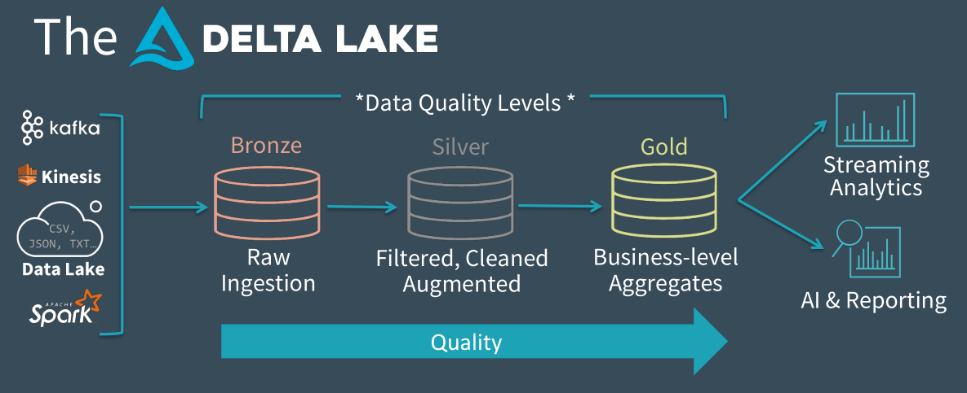

Conclusion
Databricks Delta Lake is a modern storage layer that enhances traditional data lakes with reliability, performance, and advanced data management capabilities. By providing features such as ACID transactions, schema enforcement, schema evolution, time travel, data versioning, update and delete support, and performance optimization, Delta Lake enables organizations to build scalable and trustworthy data platforms. Its ability to support both batch and streaming workloads makes it a key technology in modern data engineering, analytics, and lakehouse architectures.

Database vs Data Warehouse vs Data Lake vs Delta Lake
Introduction
Organizations generate large amounts of data from applications, websites, sensors, transactions, and business operations. Different technologies are used to store and manage this data based on its purpose. The four commonly used storage systems are Database, Data Warehouse, Data Lake, and Delta Lake.
Although they all store data, they differ significantly in terms of data type, structure, performance, scalability, and use cases.

1. Database
A Database is a system designed to store, organize, and manage structured data. It is mainly used for day-to-day operational activities known as Online Transaction Processing (OLTP).
Databases store data in tables consisting of rows and columns. They support frequent insert, update, delete, and query operations.
Characteristics
- Stores structured data
- Uses predefined schemas
- Supports CRUD operations
- Optimized for transactional workloads
- Ensures data consistency using ACID properties

Examples
- MySQL
- PostgreSQL
- Oracle Database
- Microsoft SQL Server
Use Cases
- Banking applications
- E-commerce websites
- Student management systems
- Inventory systems
- Employee management systems
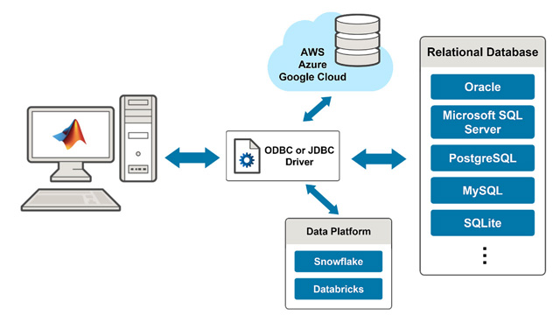

2. Data Warehouse
A Data Warehouse is a centralized repository designed to store large volumes of historical data collected from multiple sources for reporting and analytics.
Unlike databases, data warehouses are optimized for Online Analytical Processing (OLAP).
Characteristics
- Stores structured and processed data
- Supports complex analytical queries
- Integrates data from multiple systems
- Maintains historical records
- Optimized for business intelligence and reporting
Examples
- Snowflake
- Amazon Redshift
- Google BigQuery
- Azure Synapse Analytics
Use Cases
- Business reporting
- Sales analysis
- Financial analysis
- Customer analytics
- Executive dashboards

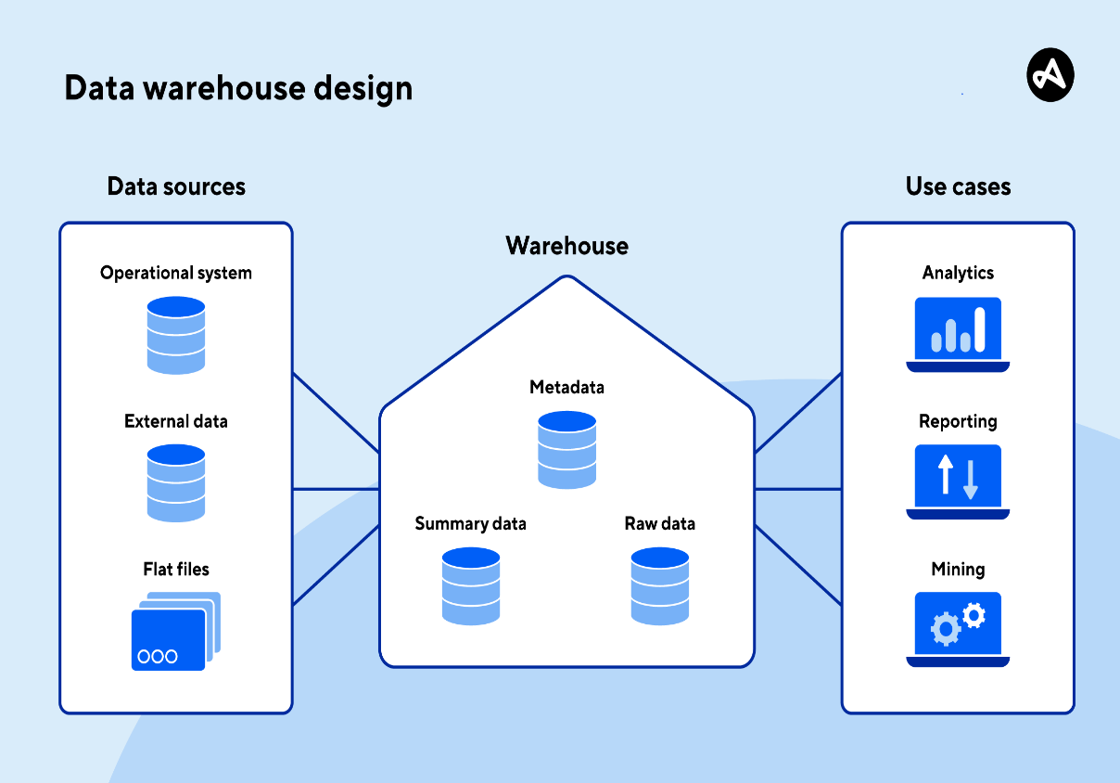

3. Data Lake
A Data Lake is a large storage repository that stores raw data in its original format. It can store structured, semi-structured, and unstructured data.
Data lakes are designed to handle massive volumes of data at low cost.
Characteristics
- Stores raw data
- Supports all data types
- Highly scalable
- Low storage cost
- Schema is applied during reading (Schema-on-Read)
Types of Data Stored
- CSV files
- JSON files
- XML files
- Images
- Videos
- Audio files
- Sensor data
- Log files
Examples
- Azure Data Lake Storage
- Amazon S3
- Google Cloud Storage
Use Cases
- Big Data Analytics
- Machine Learning
- Data Science
- IoT Applications
- Log Analysis
Limitation of Data Lakes
Traditional data lakes suffer from:
- No ACID transactions
- Data duplication
- Poor data quality control
- No version history
- Difficulty handling updates and deletes
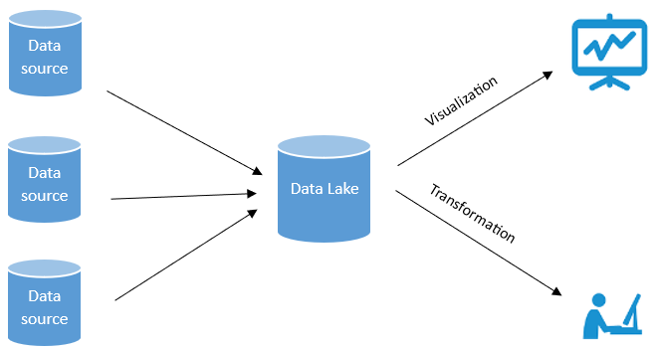

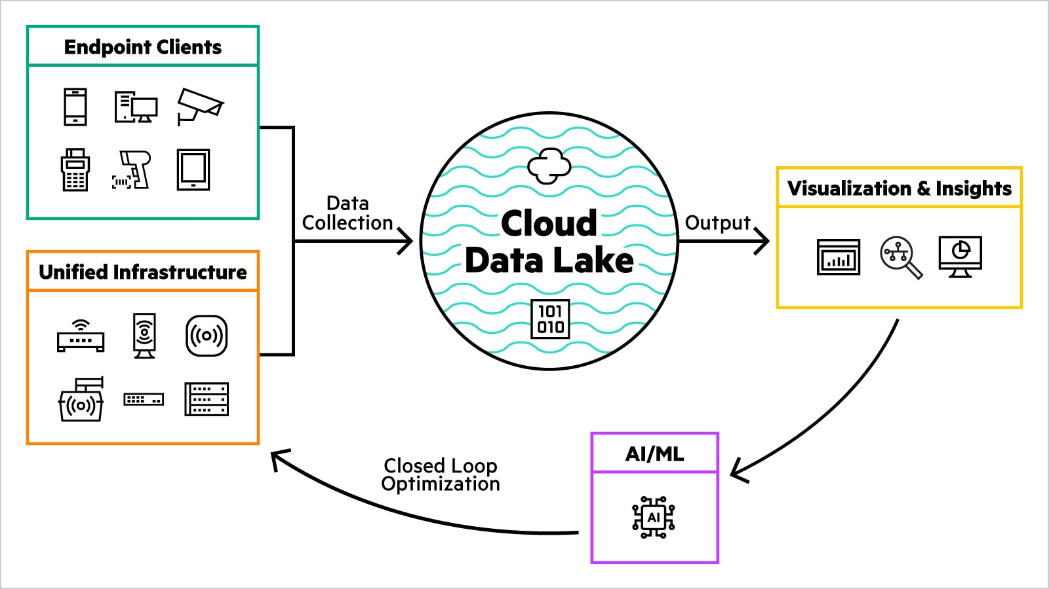

4. Delta Lake
Delta Lake is an advanced storage layer built on top of a Data Lake. It adds reliability, performance, and data management capabilities to traditional data lakes.
Delta Lake stores data as Parquet files and maintains a transaction log called _delta_log.
Characteristics
- Supports ACID transactions
- Provides schema enforcement
- Supports schema evolution
- Enables time travel
- Maintains data version history
- Supports updates and deletes
- Improves query performance
Examples
- Delta Lake
- Databricks
Use Cases
- Modern Data Engineering
- Real-time Analytics
- Machine Learning Pipelines
- Lakehouse Architecture
- Enterprise Data Platforms
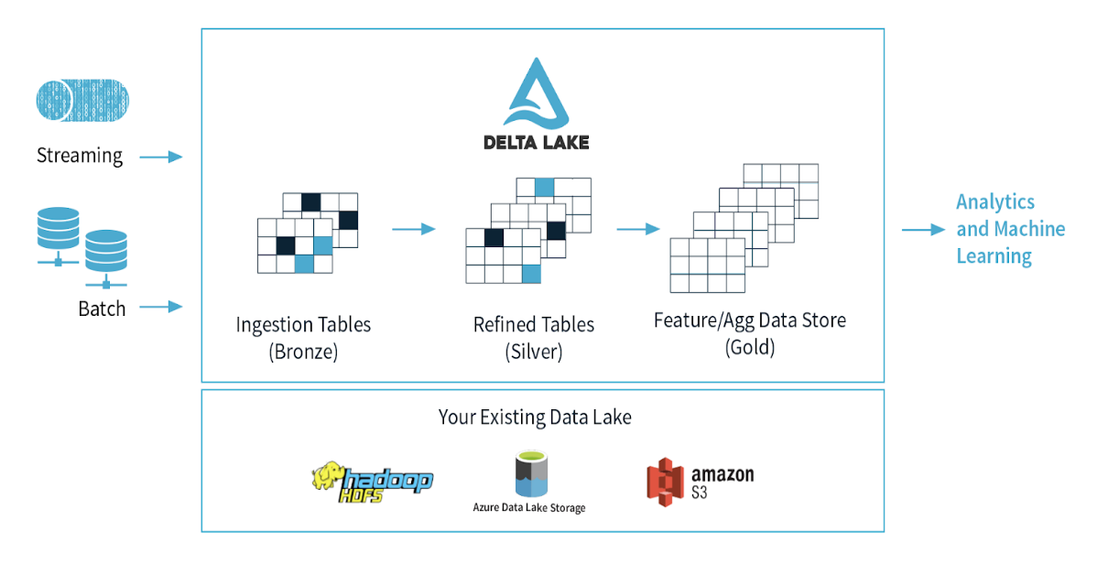
Detailed Comparison
Feature | Database | Data Warehouse | Data Lake | Delta Lake
Purpose | Transaction Processing | Business Analytics | Raw Data Storage | Reliable Data Lake
Data Type | Structured | Structured | Structured, Semi-Structured, Unstructured | Structured, Semi-Structured, Unstructured
Schema | Schema-on-Write | Schema-on-Write | Schema-on-Read | Schema Enforcement + Evolution
Storage Cost | Medium | High | Low | Low
Scalability | Limited | High | Very High | Very High
Historical Data | Limited | Yes | Yes | Yes
ACID Transactions | Yes | Yes | No | Yes
Time Travel | No | Limited | No | Yes
Data Versioning | No | Limited | No | Yes
Update/Delete Support | Yes | Yes | Difficult | Easy
Query Performance | High | Very High | Moderate | High
Streaming Support | Limited | Limited | Yes | Yes
Machine Learning Support | Limited | Limited | Yes | Yes
Big Data Support | Limited | Moderate | Excellent | Excellent

Simple Analogy
Imagine a library:
Database
A bookshelf containing books currently being used every day.
Example:
- Customer records
- Orders
- Transactions
Data Warehouse
A well-organized archive room containing years of summarized books and reports.
Example:
- Monthly sales reports
- Revenue analysis
- Business dashboards
Data Lake
A huge warehouse storing everything without much organization.
Example:
- Documents
- Images
- Videos
- Logs
- CSV files
Delta Lake
The same warehouse, but with security cameras, inventory tracking, version history, and proper management systems.
Example:
- All Data Lake capabilities
- Plus transactions, auditing, recovery, and optimization

Data Flow in Modern Data Platforms
Applications / Websites / Sensors
│
▼
Database
│
▼
Data Lake
│
▼
Delta Lake
│
▼
Data Warehouse
│
▼
Reports & Dashboards

Conclusion
A Database is used for operational transactions and day-to-day business activities. A Data Warehouse is used for reporting and analytics on historical data. A Data Lake stores massive amounts of raw structured and unstructured data at low cost. Delta Lake enhances a Data Lake by adding ACID transactions, schema management, time travel, data versioning, and performance optimization. In modern cloud architectures, Delta Lake is widely used because it combines the scalability of Data Lakes with the reliability of Data Warehouses, forming the foundation of the Lakehouse architecture.

